**VISVESVARAYA TECHNOLOGICAL UNIVERSITY**

**“JnanaSangama”, Belgaum -590014, Karnataka.**



**LAB REPORT**

**on**

**OBJECT ORIENTED MODELLING AND DESIGN**

***Submitted by***

**Srishti Dorepally (1BM19CS160)**

***in partial fulfillment for the award of the degree of***

**BACHELOR OF ENGINEERING**

***in***

**COMPUTER SCIENCE AND ENGINEERING**



**B.M.S. COLLEGE OF ENGINEERING**

**(Autonomous Institution under VTU)**

**BENGALURU-560019**

**May-2022 to July-2022**

**B. M. S. College of Engineering,**

**Bull Temple Road, Bangalore 560019**

(Affiliated To Visvesvaraya Technological University, Belgaum)

**Department of Computer Science and Engineering**



**CERTIFICATE**

This is to certify that the Lab work entitled “Object Oriented Modelling and Design Lab” carried out by **SRISHTI DOREPALLY (1BM19CS160),** who is a bonafide student of **B. M. S. College of Engineering.** It is in partial fulfillment for the award of **Bachelor of Engineering in Computer Science and Engineering** of the Visvesvaraya Technological University, Belgaum during the year 2022. The Lab report has been approved as it satisfies the academic requirements with respect to **Object Oriented Modelling and Design- (20CS6PCOMD)** work prescribed for the said degree.

Name of the Lab-Incharge               **Dr. Jyothi S Nayak**

Designation Professor and Head

Department of CSE Department of CSE

BMSCE, Bengaluru BMSCE, Bengaluru

`

**Index Sheet**

|  |  |  |
| --- | --- | --- |
| **Sl. No.** | **Experiment Title** | **Page No.** |
|  | **College Information System** |  |
|  | **Hostel Management System** |  |
|  | **Stock Maintenance System** |  |
|  | **Coffee Vending Machine** |  |
|  | **Online Shopping System** |  |
|  | **Railway Reservation System** |  |
|  | **Graphics Editor** |  |
|  |  |  |
|  |  |  |
|  |  |  |
|  |  |  |
|  |  |  |
|  |  |  |
|  |  |  |
|  |  |  |

**Course Outcome**

|  |  |
| --- | --- |
|  |  |

1. **COLLEGE INFORMATION SYSTEM**

**CLASS DIAGRAM:**

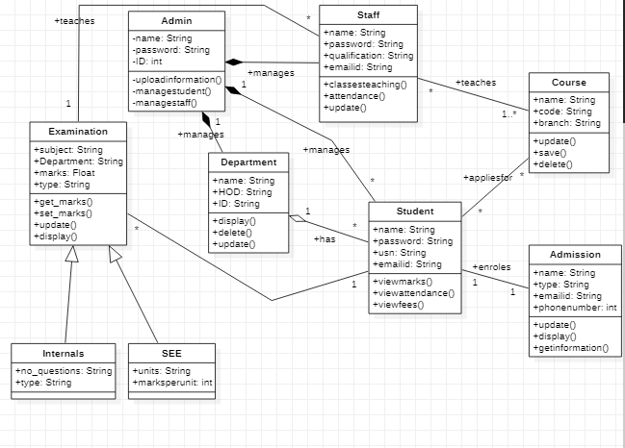

**STATE DIAGRAM:**

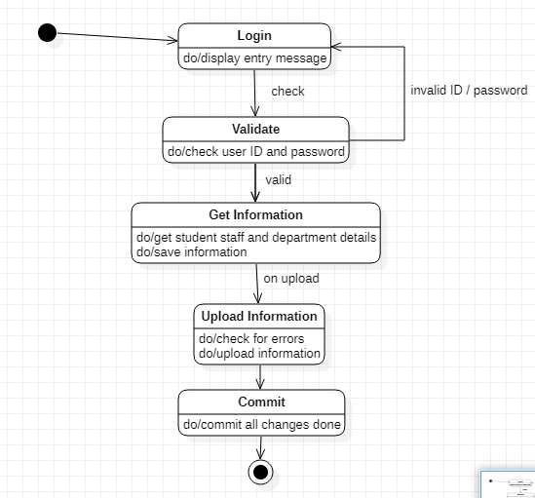

**ADVANCED STATE DIAGRAM:**

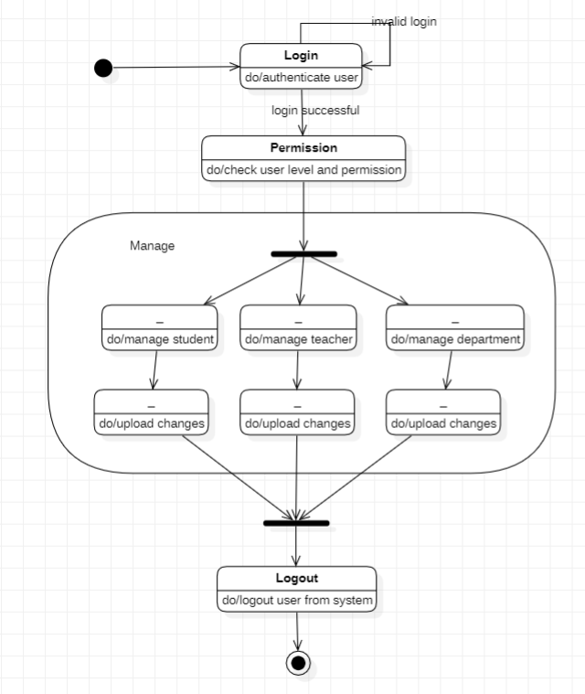

1. **HOSTEL MANAGEMENT SYSTEM**

**CLASS DIAGRAM:**

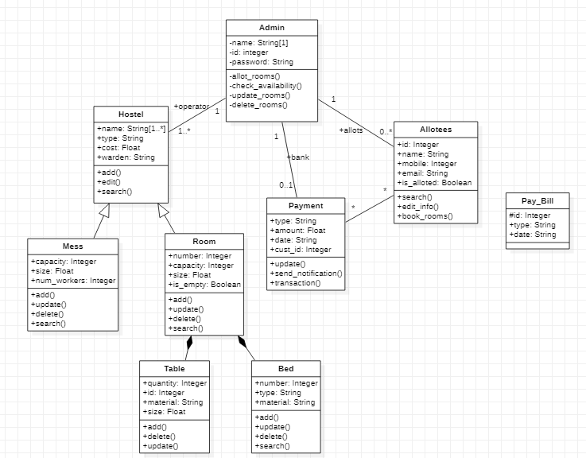

**STATE DIAGRAM:**

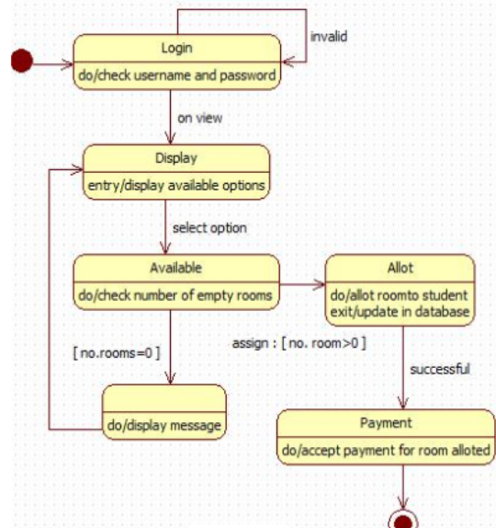

1. **STOCK MAINTENANCE SYSTEM**

**CLASS DIAGRAM:**

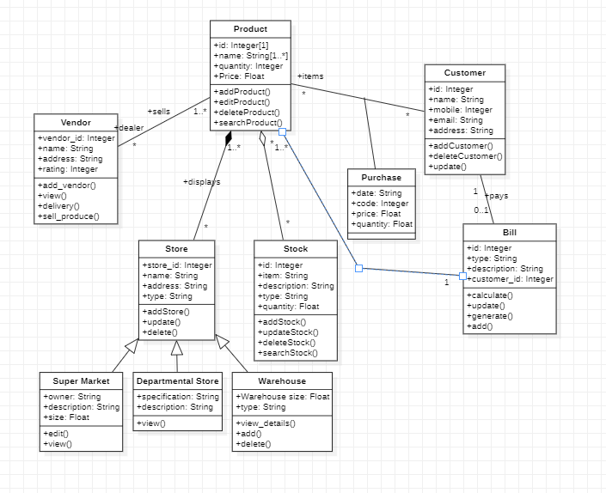

**STATE DIAGRAM:**

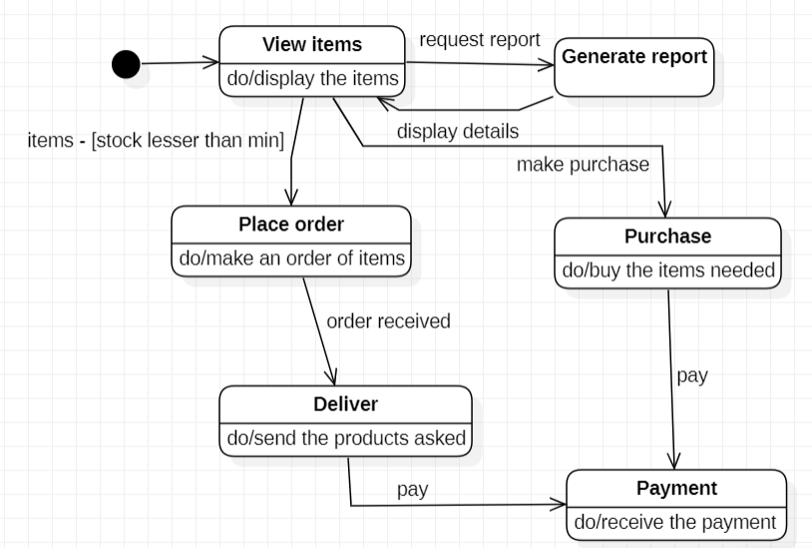

1. **COFFEE VENDING MACHINE**

**CLASS DIAGRAM:**

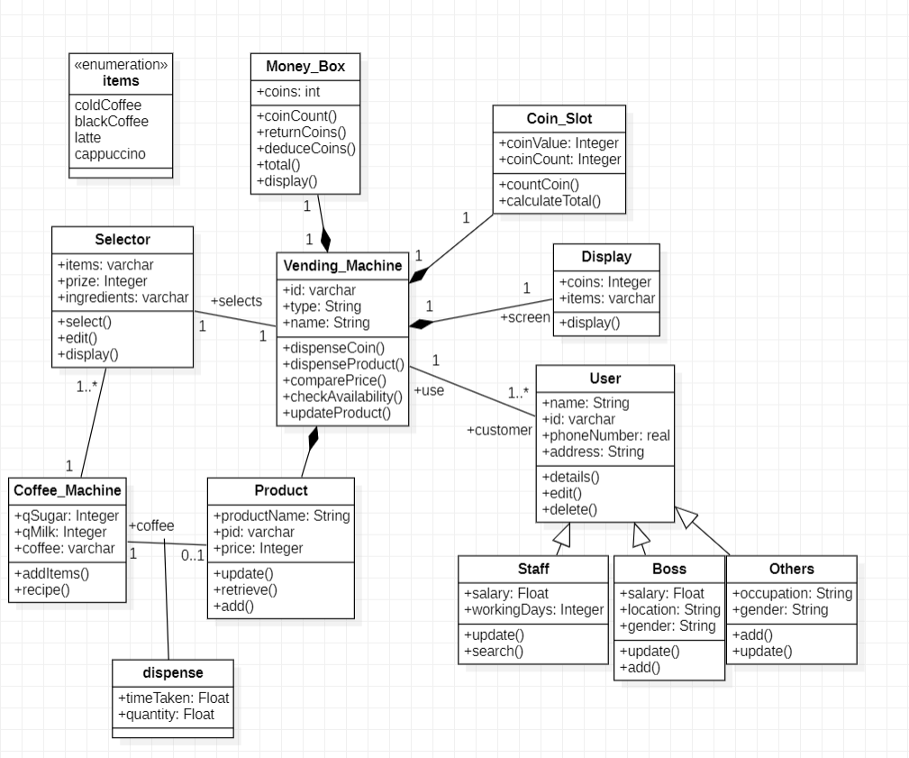

**STATE DIAGRAM:**

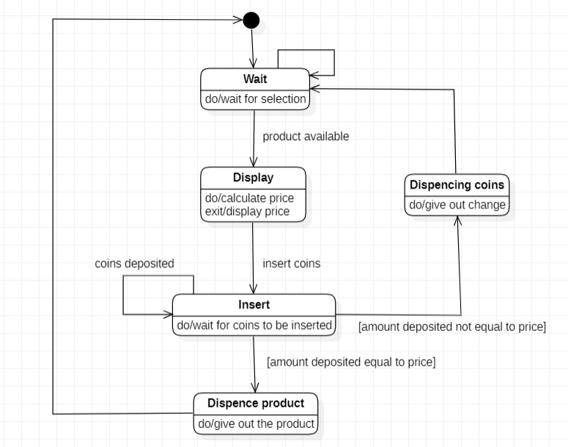

1. **ONLINE SHOPPING SYSTEM**

**CLASS DIAGRAM:**

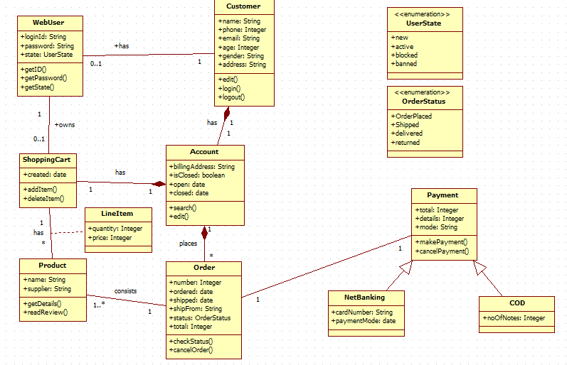

**STATE DIAGRAM:**

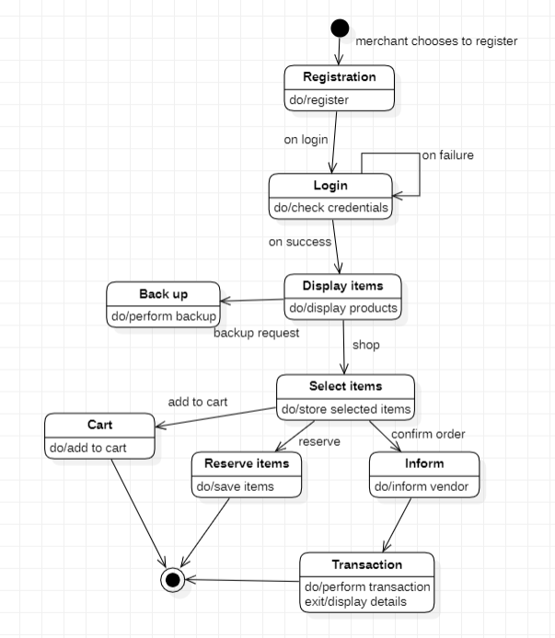

1. **RAILWAY RESERVATION SYSTEM**

**CLASS DIAGRAM:**

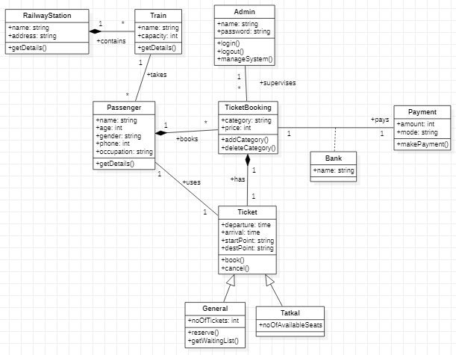

**STATE DIAGRAM:**

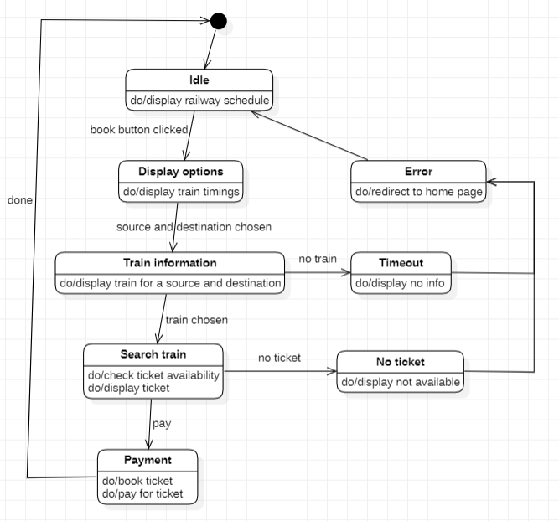

1. **GRAPHICS EDITOR**

**CLASS DIAGRAM:**

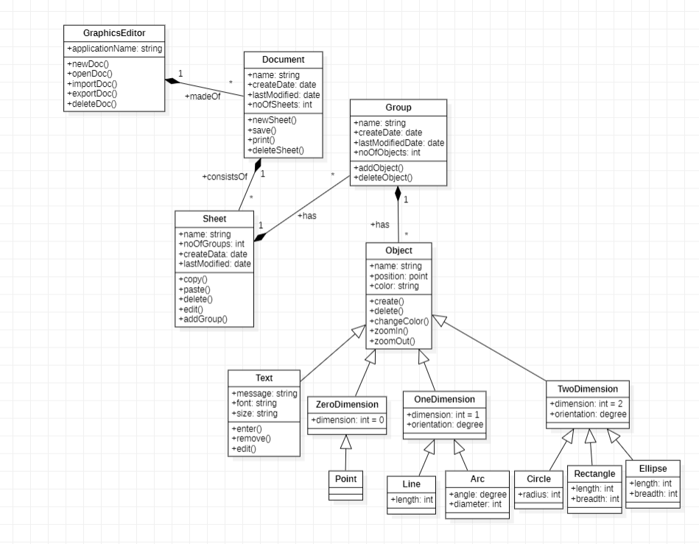

**STATE DIAGRAM:**

